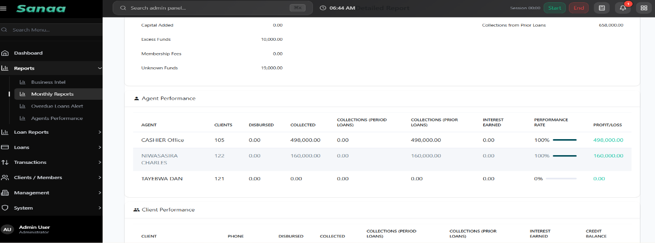

Monthly reports; put expenses on financial summary and agent performance and agent collections and performance titles are not clear as I don’t know the formulae used and interest earned, if you can improve the agent table. Then you can remove client performance on export report.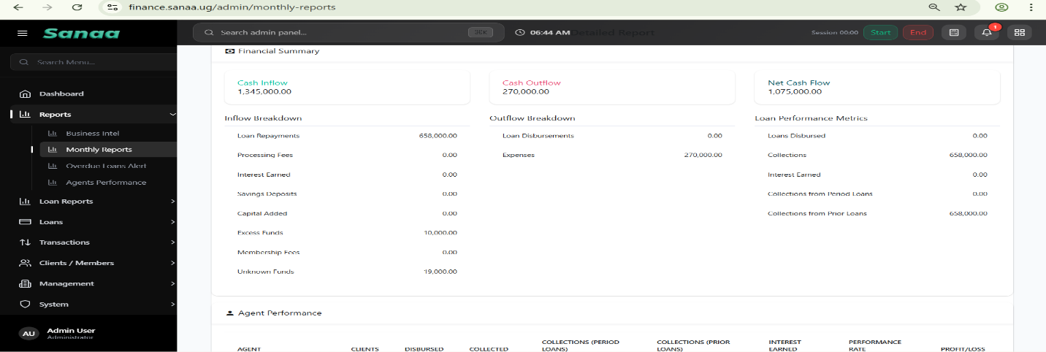

On the Overdue loans, add loan taken dates and guarantor contact
o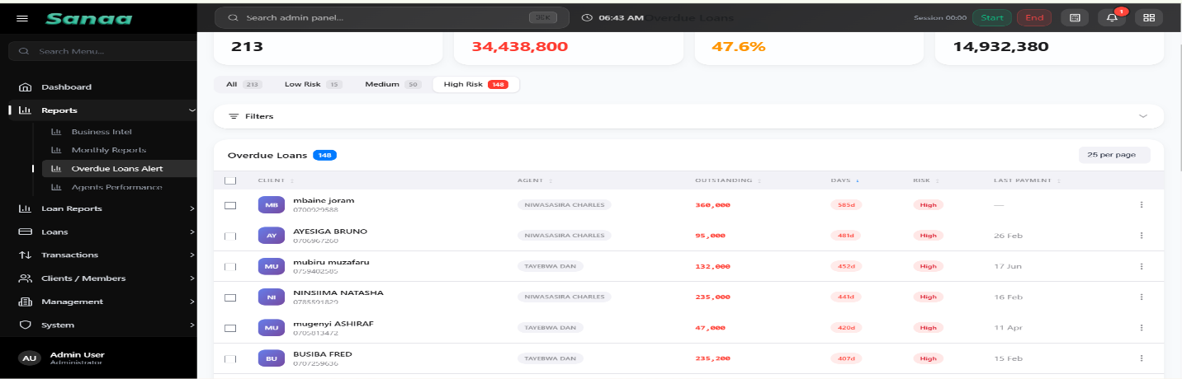

Still on overdue loans and any other field where you have clients or loans can’t we have a total on the top column for each that requires total amounts or summation like here similar to the summaries you put on top of your reports 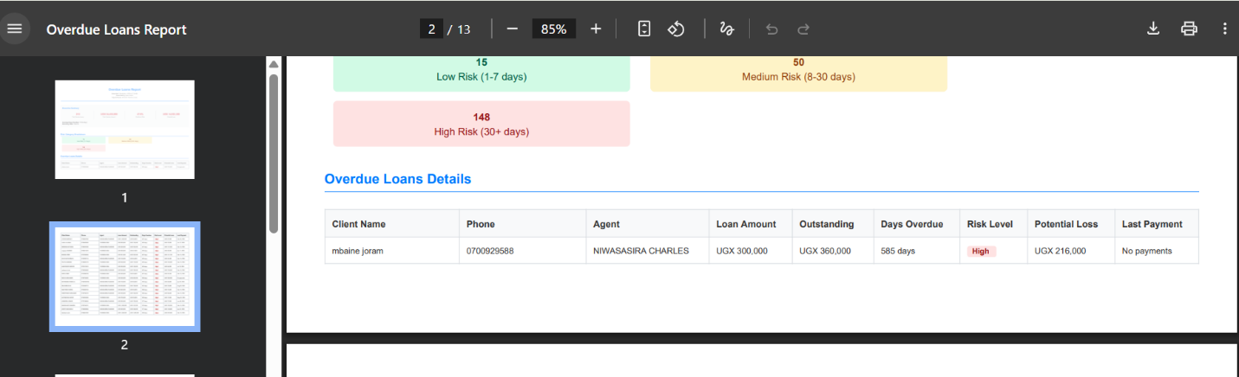

On agent performance and data entry ensure that expenses are categorical such that every expense is put under the owner like its done on loans. This way, administration expenses should not be under the cashier expenses but rather the branch expenses 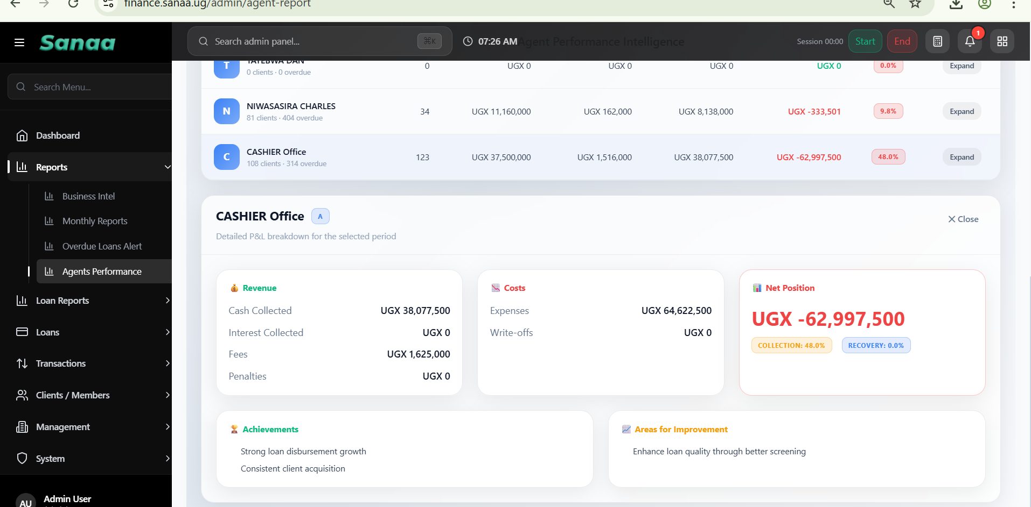

With that worked we can have an improved table not with such a loss 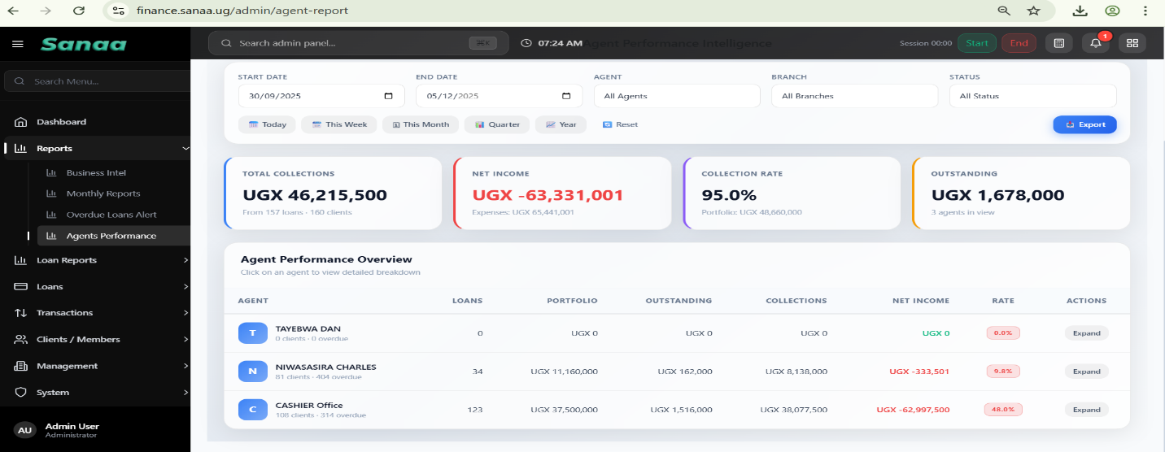

Loan reports and loan analysis is not working, it shows error and the daily report, net cash flows means, can’t we have cash inflows, cash outflows and expenses and processing fees or other cash and total cash inflow instead of net. Something that requires one not to think even if they are new in the industry. And Operations snap shot, can’t we use another wording? Replace net cash with closing balance on the executive summary for simplicity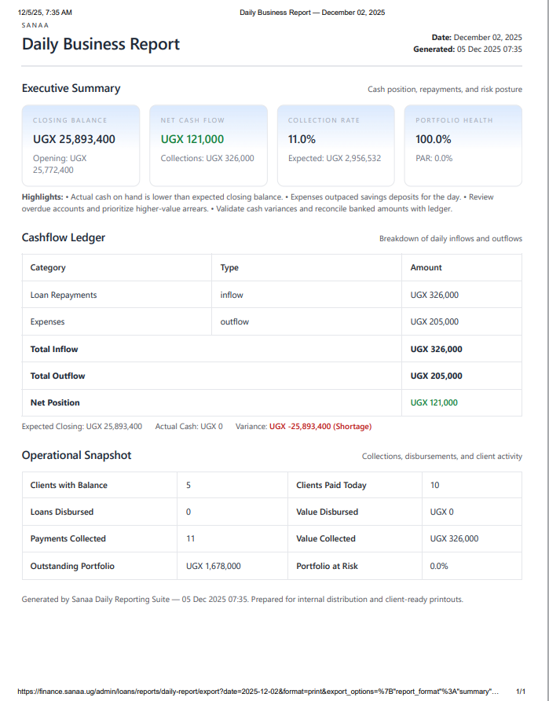

Arrears data does not show
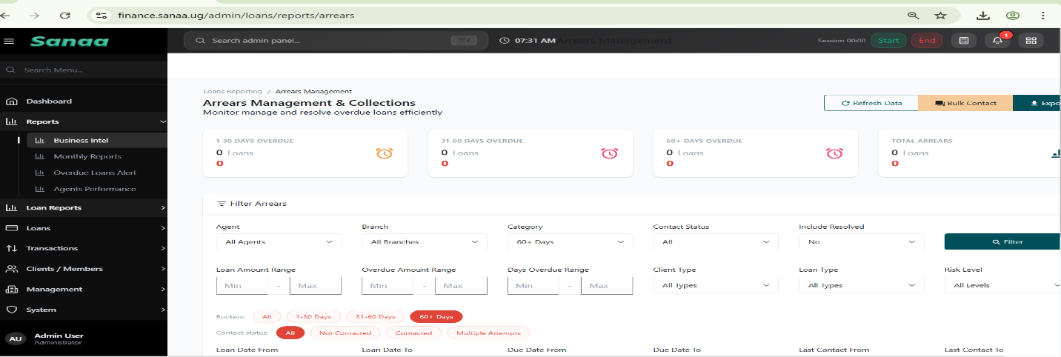

Expense recording, selection of the person who used the money in question should be worked on its not active 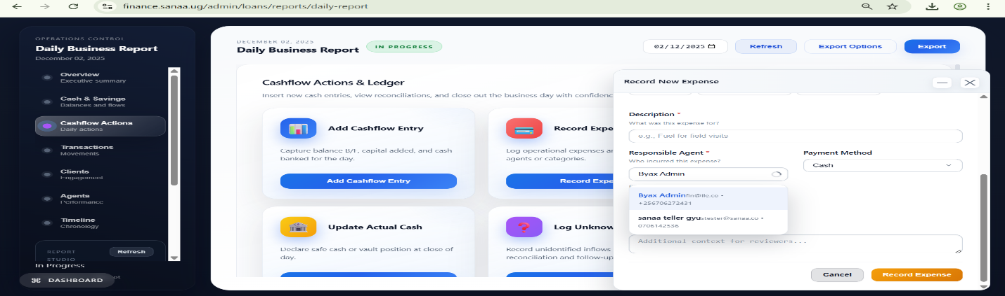

Under amount; Zero on excess funds for clients’ entry cannot be automatically removed when typing and it needs a forced delete. Can’t we improve it? 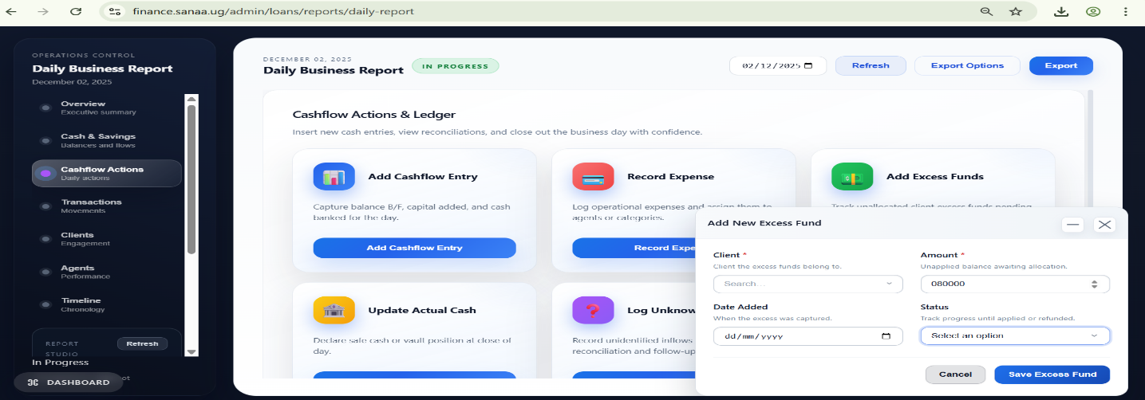

We should add shortage for agents on the cash flow entries and be linked to loans of clients where money is missing and that way the clients balance can be reduced by the shortage entry. Wh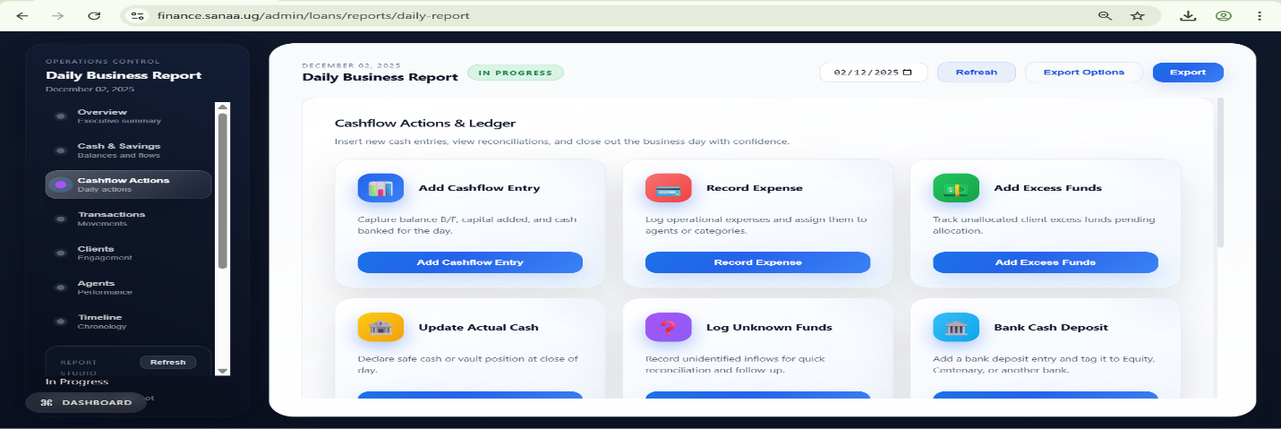
Clients cannot load; and latter is signs out. On the client listing on this dashboard and I review it again and put export option on collection reports and per agent as well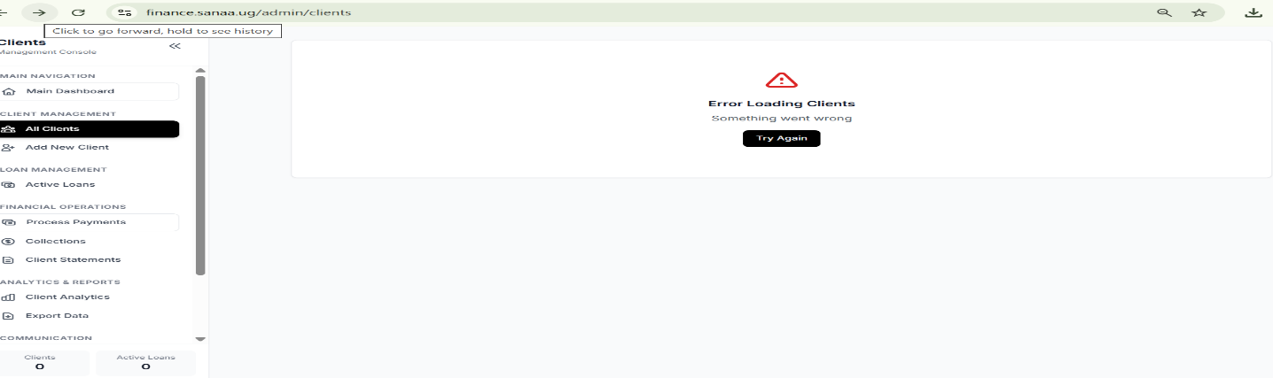
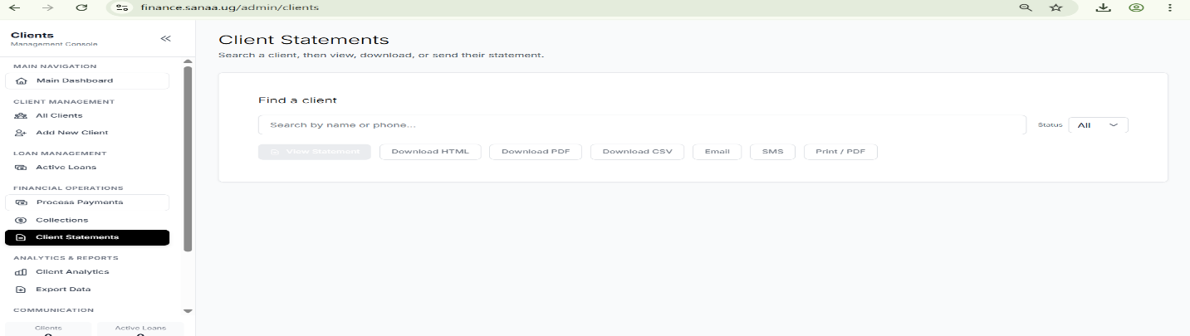
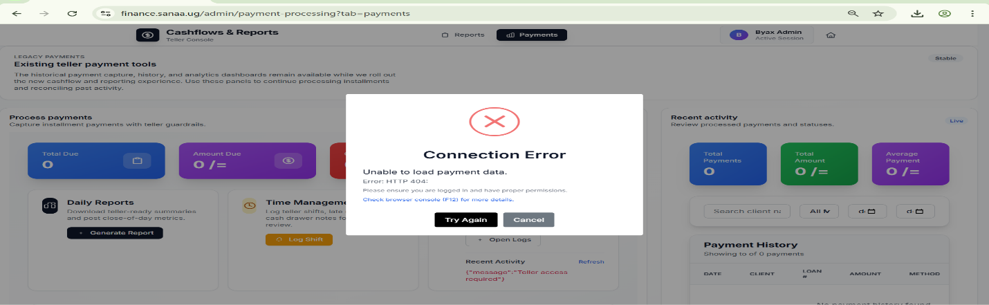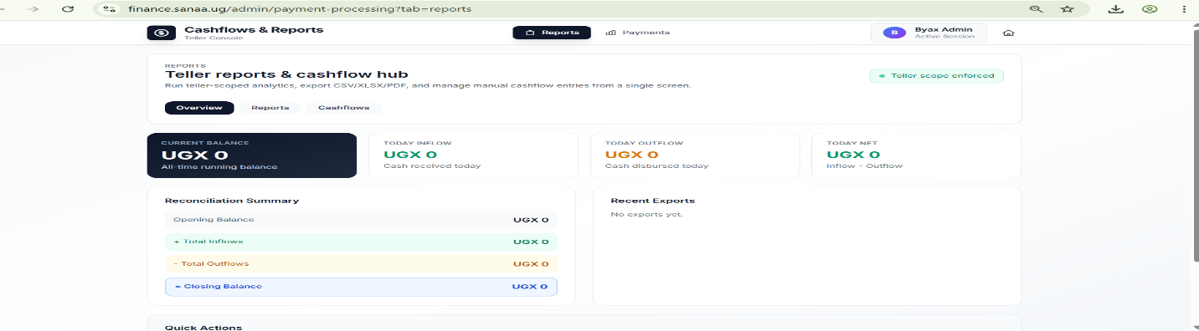
On Running loans, can’t we replace paid amount with loan taken date and add the agent on the filters and include the export button as well? 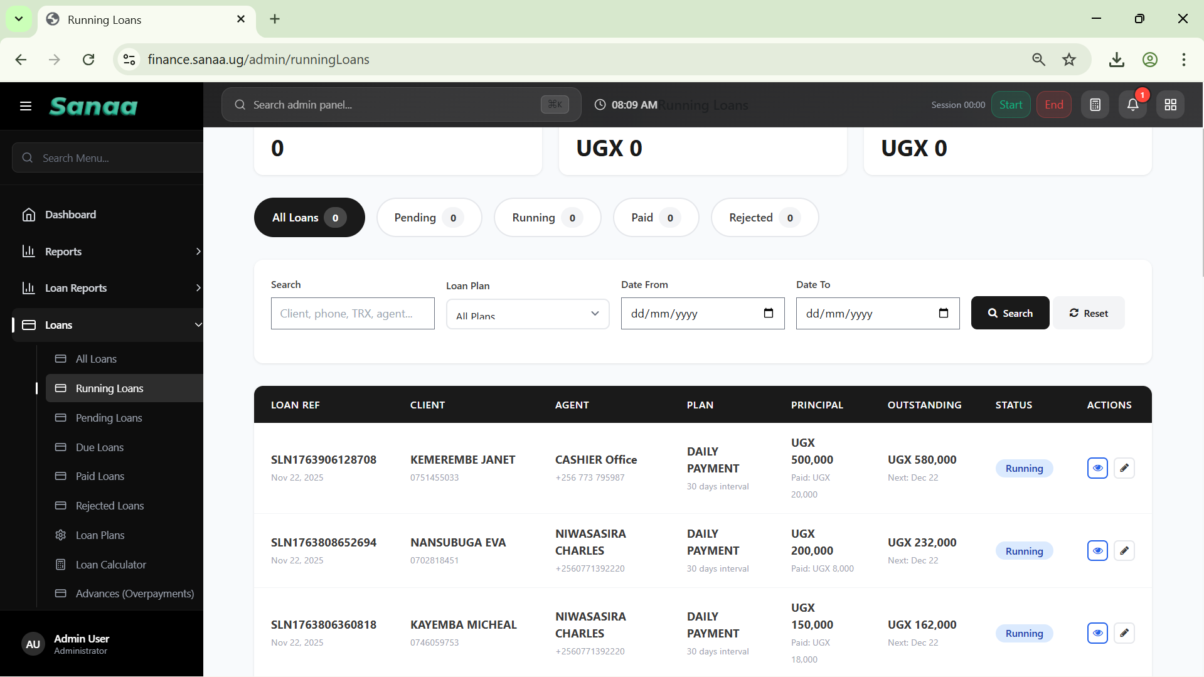
Pending loans can have a summary as well and export button to identify the number of clients who applied for money and are not yet served, we should be able to remove the pending loan if clients are not cashed or have running loans automatically to avoid the confusion due to error or double entry. Pending loans can be organized and with icons or options to move them to rejected loans, error or double entry loans be removed automatically or manually and more per agent and client location. We expand the filters to include age, agent, location, business type, sex 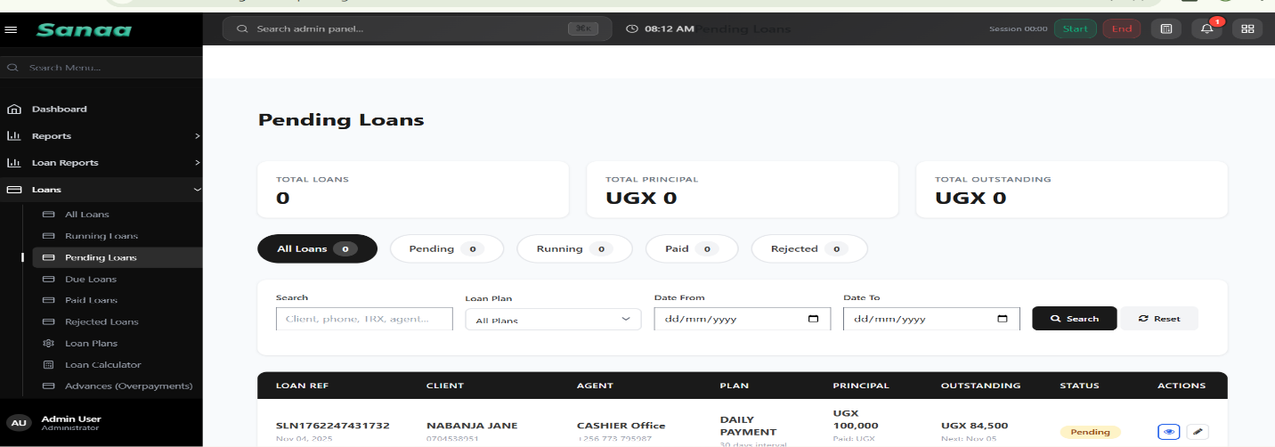
I would Cleared loans to paid loans to avoid the confusion, if we can update this throughout, the better 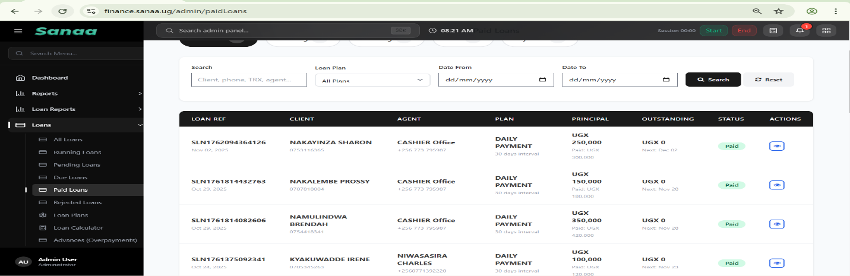
You can look into collections export reports to make sure that we can select per agent and export well. With summaries to match the field book collections for easy reconciliation. With agent details, agent collection report 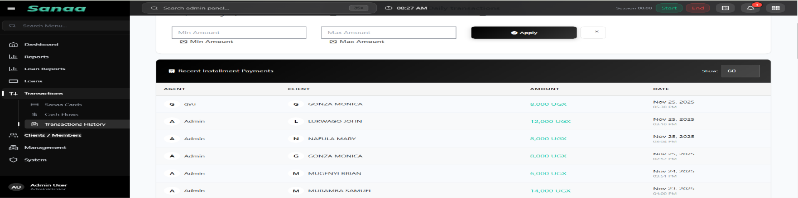

Agent details should reflect very well where they have to, this will help to evaluate the performance based on individual contribution.

